Superhero School

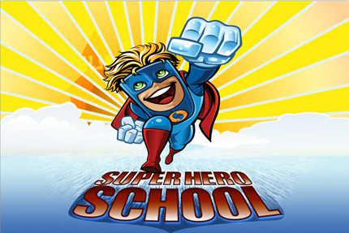

Name: _____________________

Name Tag

My name is
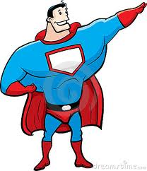

My name is
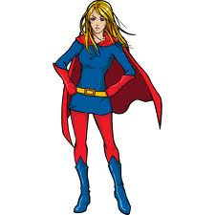

Blank Page

Blank Page

Let’s Sing a Song!

I'm a superhero! (Superhero!)
I'm a superhero! (Superhero!)
Super, superhero!
I can jump (I can jump)
I can run (I can run)
I can hide (I can hide)
I can cook (I can cook)
I'm a superhero! (Superhero!)
I'm a superhero! (Superhero!)
Super, superhero!
I can stretch (I can stretch)
I can climb (I can climb)
I can swim (I can swim)
I can fly (I can fly)
I'm a superhero! (Superhero!)
I'm a superhero! (Superhero!)
Super, superhero!

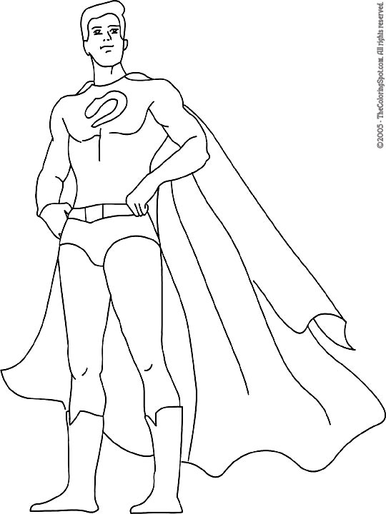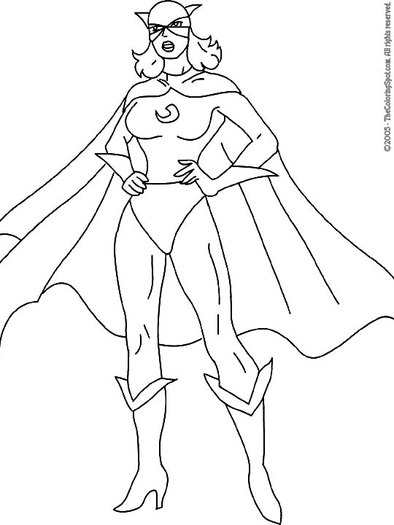

Name that Superhero
Find the Superhero Names
J L J W M S M K Y I W Z E I H  I N I Q W C A T W O M A N B N  Y Y U V V M G A M A G M G O A  T Q Y P P Y Y A J O W S R T W  Y R C W G K N Z Z Y T I A E A  M S K E B W Y U H X P J O S W  G P N T W Y Q K Q E G Z J N X  M I C A O Z O T V I N L E A G  E D F R M O D R V N E X R M X  W E R Q D L M B T Y I E D R R  E R C G K S W I Y V D K A E T  A L Y J Y I B A T M A N N P L  A M S U P E R W O M A N J U N  S W Q Z X T K W X V U P D S O  W Z Z G J Z U A Y Q B E F K B | BATMAN  SUPERMAN  IRON  MAN  SUPERWOMAN  CATWOMAN  SPIDER  WOMDER  WOMAN

Write the Name
Iron Man(아이언맨) Spider-Man(스파이더맨) Batman(배트맨) Superman(슈퍼맨)

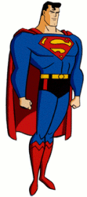 | Hi, my name is  ___________________! | 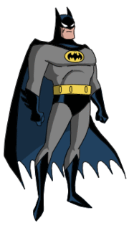 | I’m  ____________________.
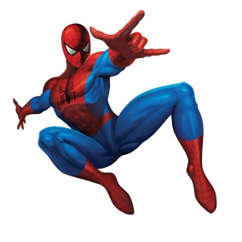 | My name is  ___________________. | 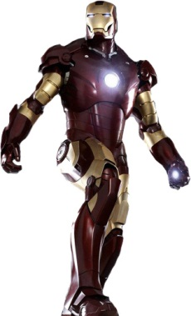 | I’m  ______________________!

Costumes
Write the correct item of clothing:

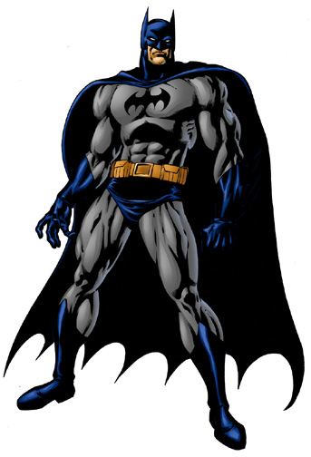
4
6
5
3
2
1
mask cape boots shirt gloves pants

Color the Superhero:
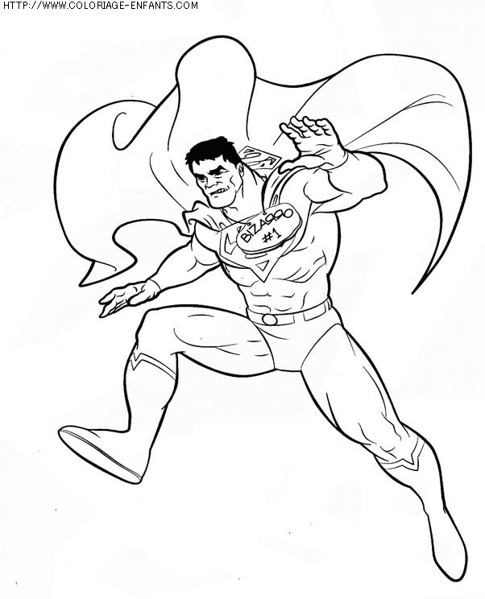

Unscramble the words:
purple red yellow pink blue orange green white black
1. 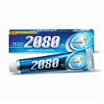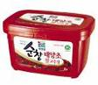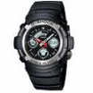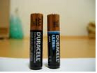ulprpe ___________
2. der ___________
3. lbue ___________
4. lleyow ___________
Super Powers 1
A B P F S P V L D Q P U  R Y J P O F D P C O H Q  F L M B Q S H M A B G R  W N Y F L Y W C D K L I  H N V U F L W I V R N E  D D R Z K M E Z M R X E  Z L S N S F L F K C H D  C J J X V H K F K P L N  C L C V U G E P I O Q R  K A I D E N V G N U R P  N P L M C S T E I F D W  N T Q P B T B V L B B S | FLY (날다)  RUN (달리다)  CLIMB (기어 오르다)  SWIM (헤엄치다)  CAN  HE  SHE

Match the numbers with the missing letters!
A | B | C | D | E | F | G | H | I | J | K | L | M | N | O | P | Q | R | S | T | U | V | W | X | Y | Z
3 | 5 | 4 | 6 | 15 | 17 | 21 | 19 | 8 | 13 | 7 | 1 | 24 | 22 | 11 | 9 | 26 | 10 | 25 | 23 | 2 | 14 | 12 | 18 | 16 | 20
___ ___ ___ ___ ___ ___ ___ ___ ___ ___!
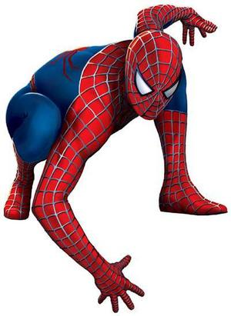
19 15 4 3 22 4 1 8 24 5

A | B | C | D | E | F | G | H | I | J | K | L | M | N | O | P | Q | R | S | T | U | V | W | X | Y | Z
5 | 8 | 4 | 1 | 25 | 16 | 15 | 12 | 14 | 11 | 22 | 23 | 20 | 3 | 19 | 7 | 2 | 10 | 18 | 21 | 17 | 24 | 9 | 26 | 6 | 13
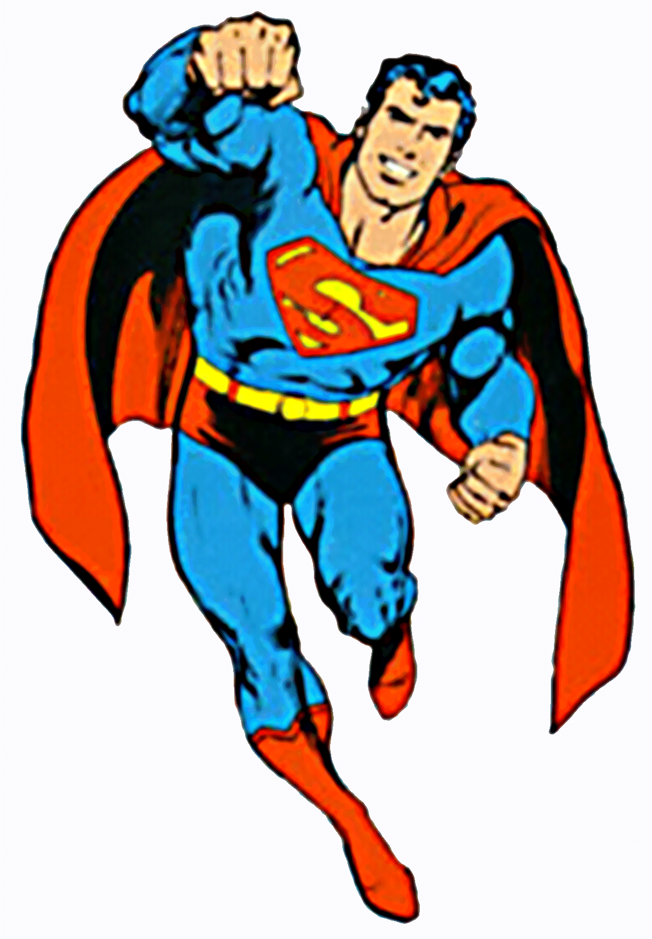
___ ___ ___ ___ ___ ___ ___ ___!
12 25 4 5 3 16 23 6

Blank Page

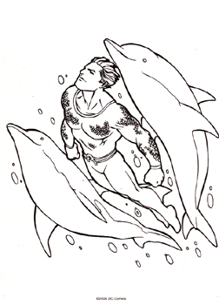He can swim.
She can swim.
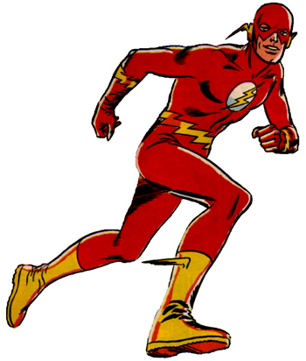She can run.
He can run.
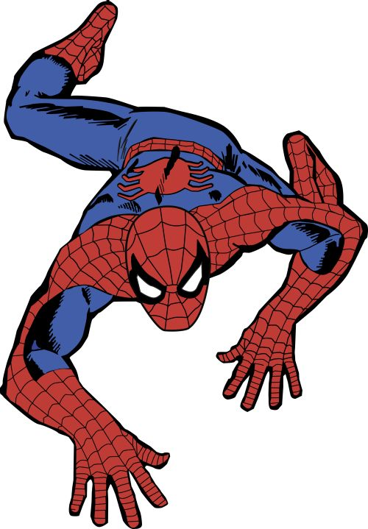She can climb.
He can fly.
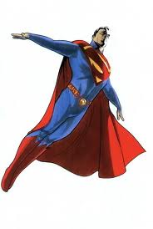He can fly.
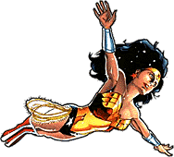She can fly.

Blank Page

Story Time
This is my bear. His name is Bubbles. He is just a bear, but he THINKS he is a superhero. He likes to dream. When he dreams…
He can fight 100 ninjas. He can run really fast. He can climb walls. He can fly. He can swim in the ocean. But when he wakes up, he can’t. He has a big belly. So he cannot fight ninjas or run really fast or climb walls or fly or swim. He can eat.

Make a Comic: fly swim climb run
He can _____________. | He can _____________.
He can _____________. | He can _____________.
Super Powers 2
Listen and Number:
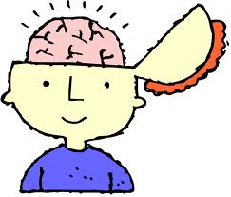
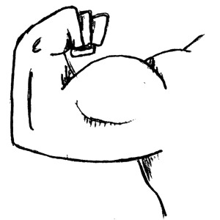

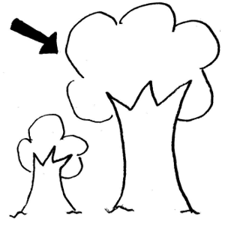
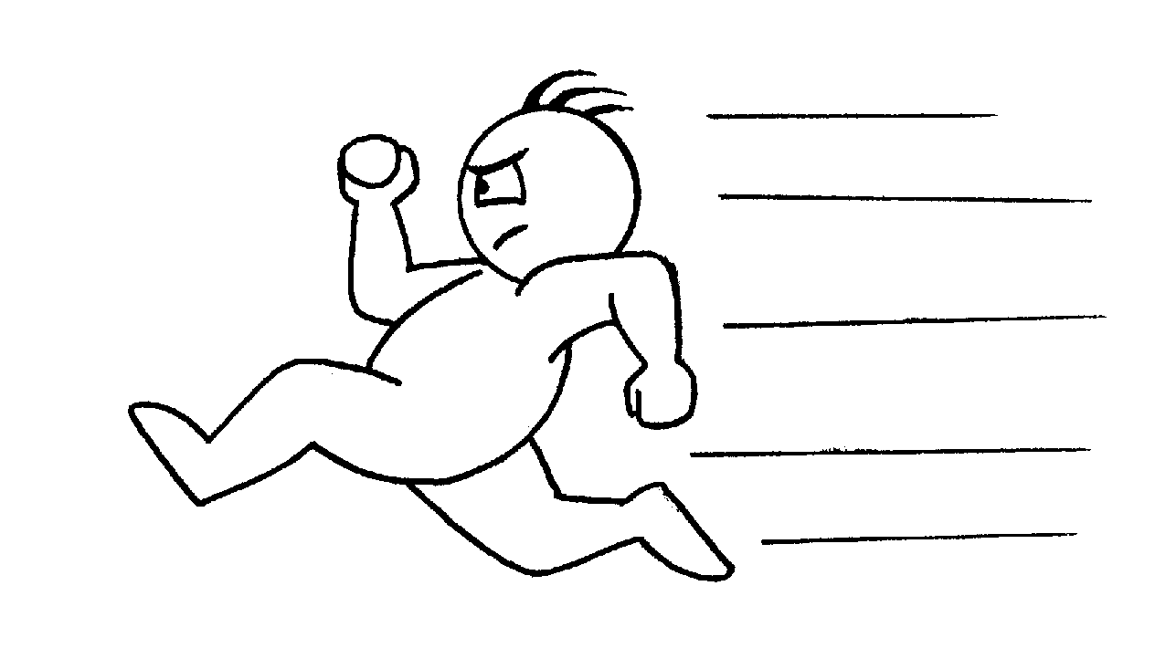

Unscramble the words:
fast
big
smart
strong
fat
- gib ______
- marts ______
- ronstg ______
- fsta ______

Draw your superhero's costume.
Color in the picture and then write in English about your superhero.
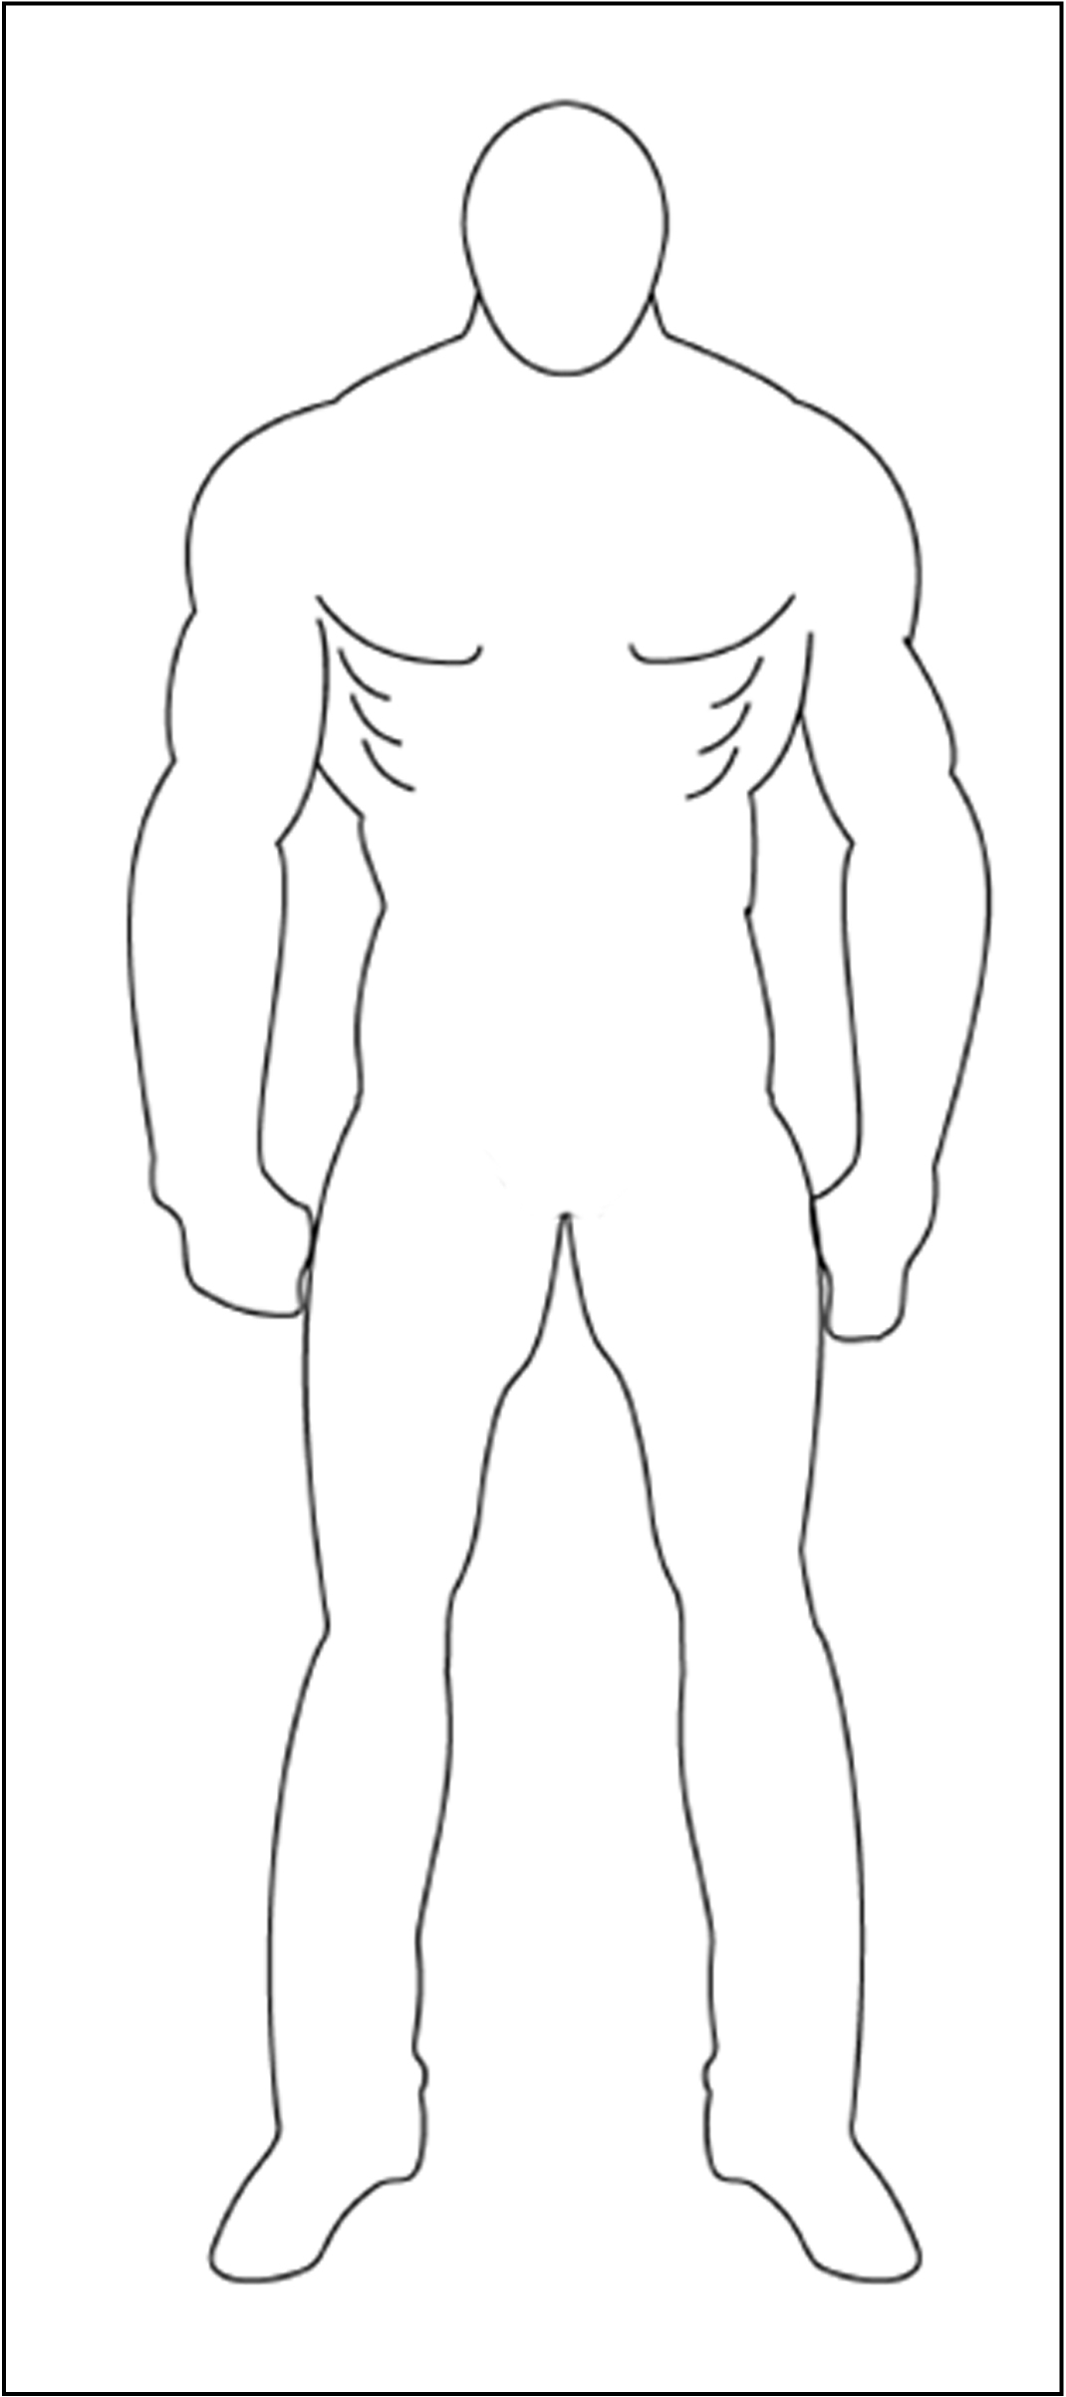 | fight (싸움) move fast (빨리 운동)  swim (수영) jump (도약) fly (비행)  run (달리다) | What does he look like?  Superhero Name (이름): ________________________________.  red green blue purple yellow orange white black grey  He has a ________________ shirt (셔츠).  He has _______________ pants (바지).  He has _______________ gloves (장갑).  He has _________________ boots (부츠).  He has a ______________ mask (마스크).  He has a _________________ cape (망토).  What can he do?  He can______________________.  He can______________________.
Draw your superhero's costume.
Color in the picture and then write in English about your superhero.
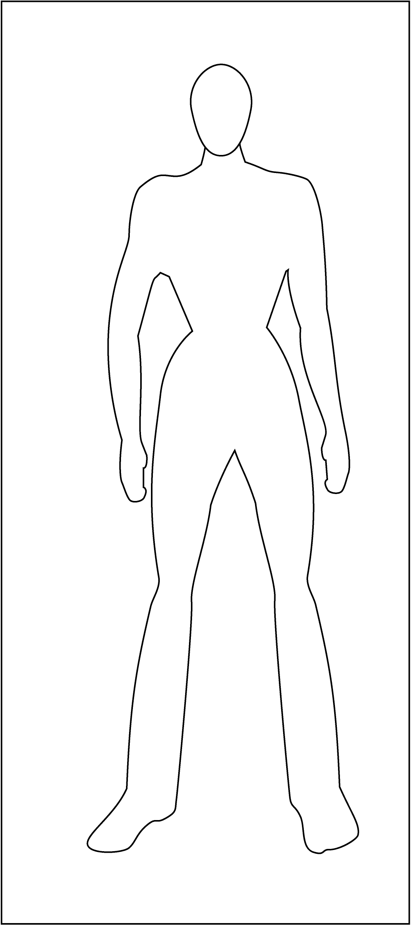 | fight (싸움) move fast (빨리 운동)  swim (수영) jump (도약) fly (비행)  run (달리다) | What does he look like?  Superhero Name (이름): ________________________________.  red green blue purple yellow orange white black grey  She has a ________________ shirt (셔츠).  She has _______________ pants (바지).  She has _______________ gloves (장갑).  She has _________________ boots (부츠).  She has a ______________ mask (마스크).  She has a _________________ cape (망토).  What can he do?  She can______________________.  She can______________________.
Super Review!
Match the words to the pictures:
Strong Smart Fast Big

Fill in the blanks:
climb
run
swim
fly

- He can ______________(오르다.)
- He can ______________(날다).
- He can ______________(달리다).
- He can ______________(헤업치다)/
Draw:
gloves
mask
cape

Help Batman get the bad man!
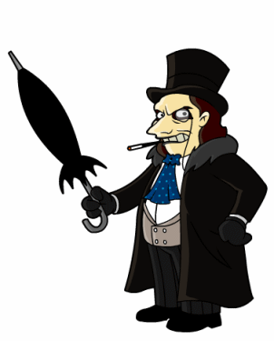
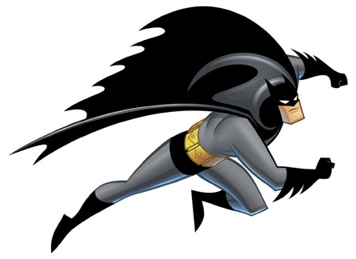

Blank Page

